**CAP 454: LINUX AND SHELL SCRIPTING - LABORATORY**

**CONTINUOUS ASSESSMENTS (C.A)-2**

**ST_NAME: - EKHLAKH AHMAD**

**REG NO.: - 12209166**

**ROLL NO.: - RD2215B67**

**SECTION: - D2215**

**GROUP: - 2**

**Q. Find vsftpd package and perform the following modes of operation:**

1. **Install**
2. **Query**
3. **Verify**
4. **Upgrade**
5. **Delete**

**Process: -**

* Open Linux. And Login root user.
* Click on VM🡪Removable Devices🡪CD/DVD(IDE)🡪Settings.
* Check connected check box.
* Click on Browse…
* Select CD3.
* Click on ok button.

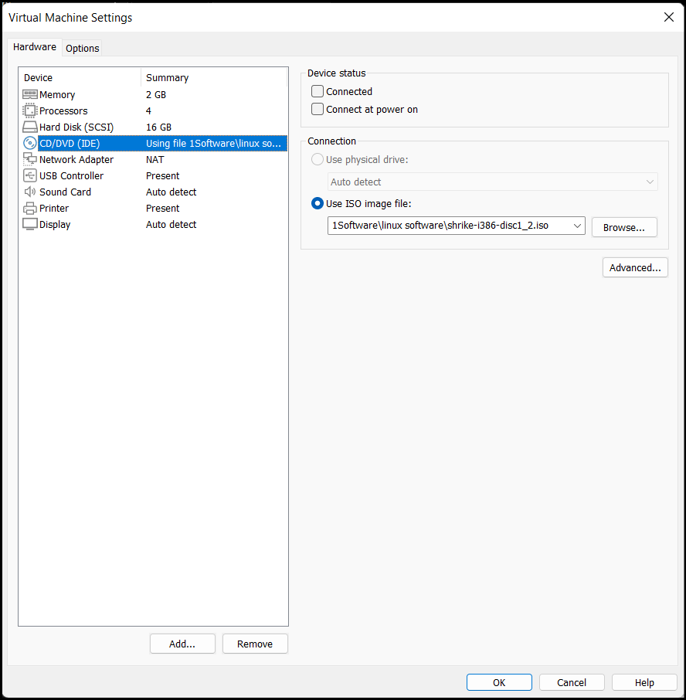

* Then a dialog box will be open in GUI base.
* Click on No button.
* Select RedHat.
* Select RPM.
* Select vsftpd package.
* And copy location/path of package.
* Open new Terminal.

**1). install: -**Type rpm -ivh and paste file path then press enter key.

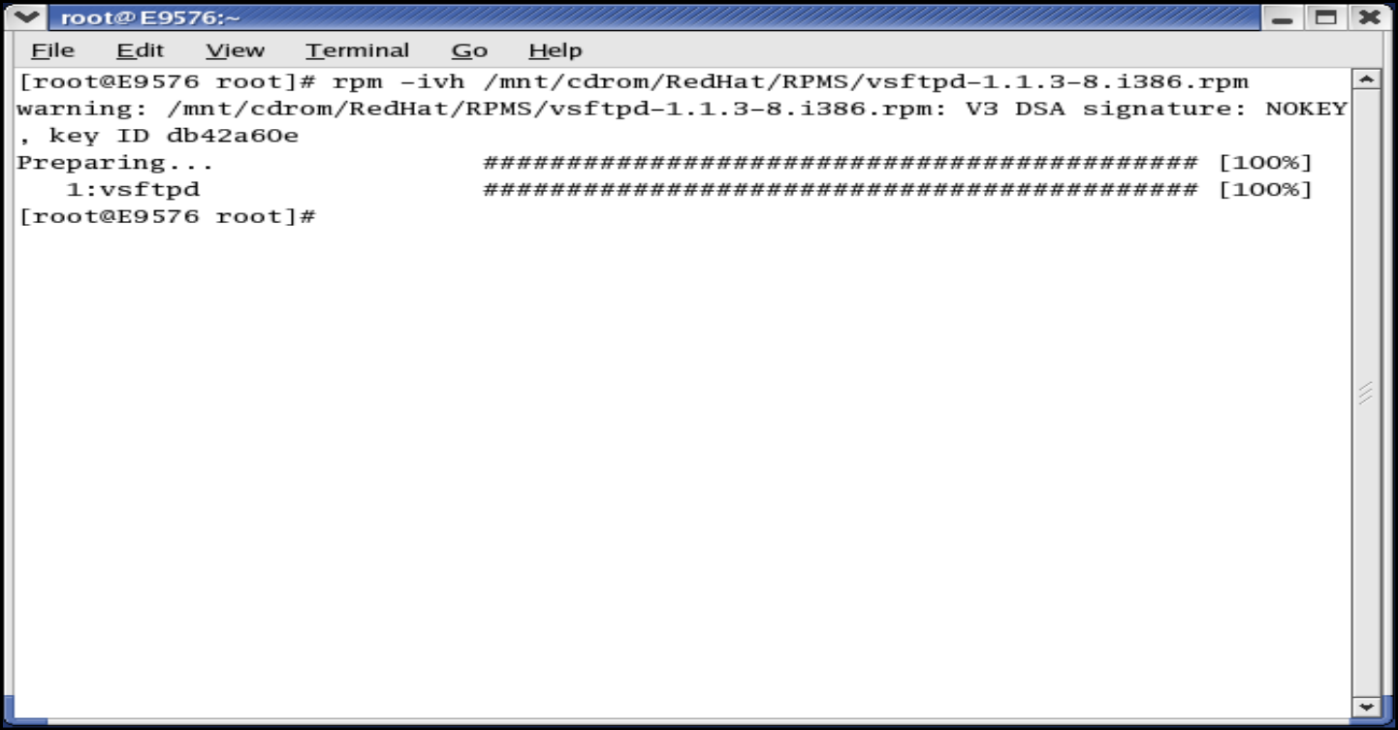

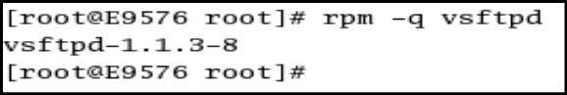**2). Query: -** Type rpm -q package_name

**3). verify: -** Type rpm -v package_name

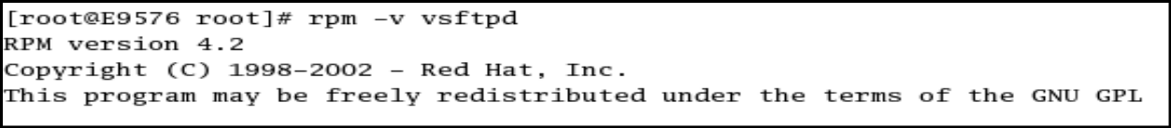

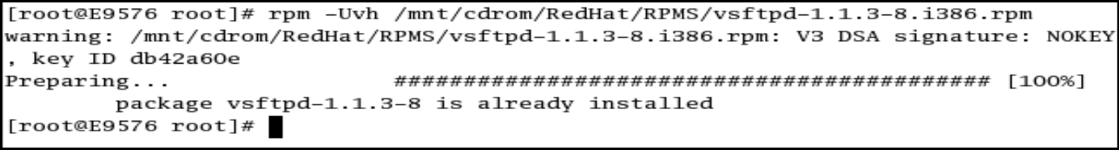**4). upgrade: -** Type rpm -Uvh paste package path

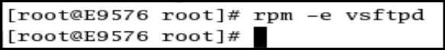**5). delete: -** Type rpm -e package_name

**Q. Create a file MCA.txt and add some data to this file related to program MCA. Now link a file Sem1.txt with MCA.txt using hard link. And perform the following : -**

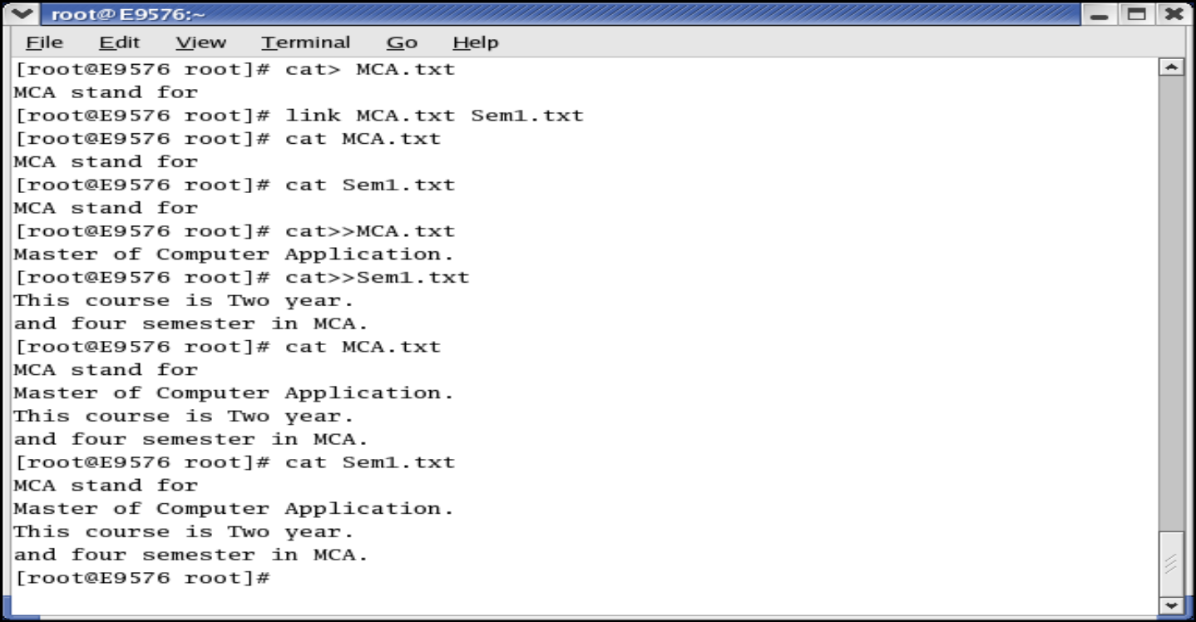1). Append data to both the files one by one and view the changes in both file

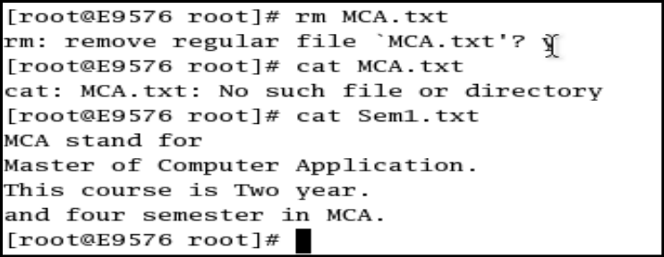2). Delete original file and view content of original and linked file**.**

**Open linked**

**Open original**

**Delete original**